1. What are the new tags added in HTML5 ?

* The commonly used new HTML5 tags are <figure>, <article>, <header>, <main>,<footer>, <nav>, and <section>.

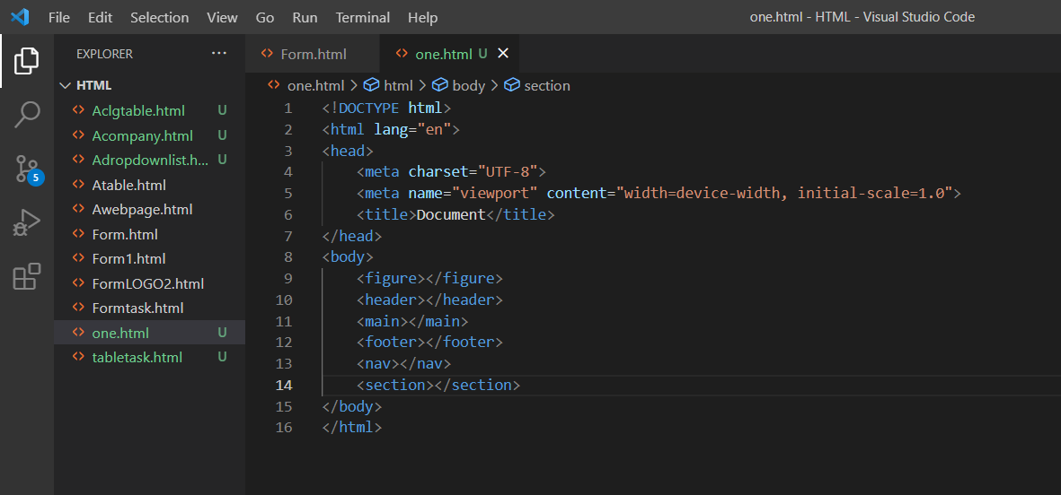

1. How to embed audio and video in a webpage?

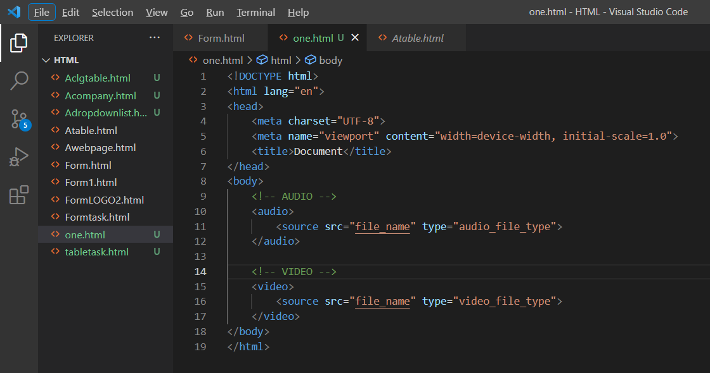

1. Semantic element in HTML5?

* <article>
* <aside>
* <details>
* <figcaption>
* <figure>
* <footer>
* <header>
* <main>
* <mark>
* <nav>
* <section>
* <summary>

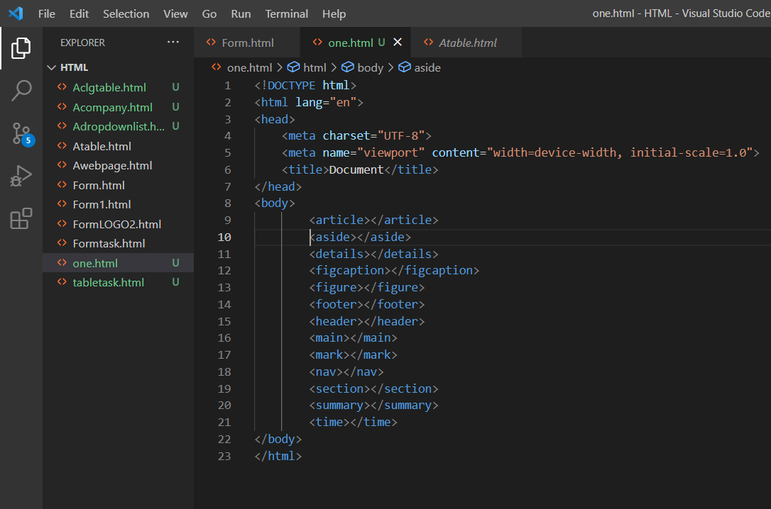

1. Canvas and SVG tags

<svg id="svgelem" height="200">

<circle id="greencircle" cx="60"

cy="60" r="50" fill="green" />

</svg>

<canvas id="newCanvas" width="100" height="100"

style="border:1px solid #000000;">

</canvas>